# Progetto ristorante

## Breakpoint xs (<576px)

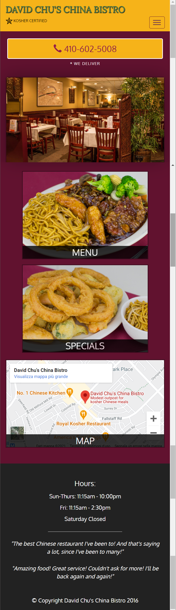

## Breakpoint sm (>=576px)

come xs

## Breakpoint md (>=768px)

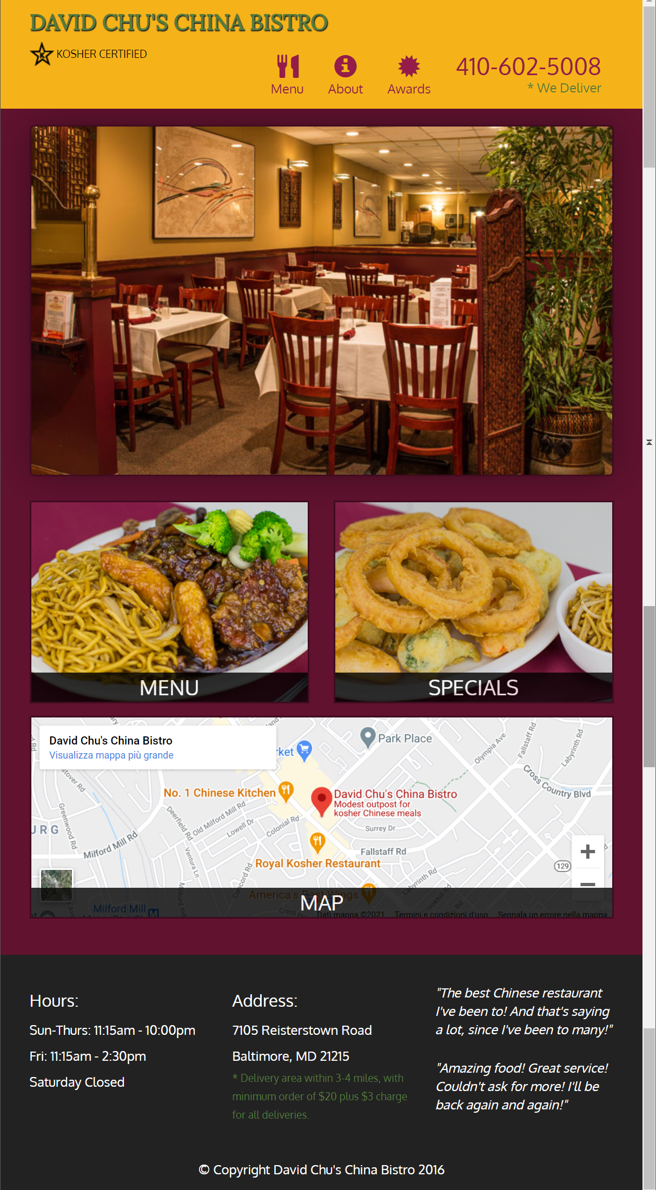

## Breakpoint lg (>=992px)

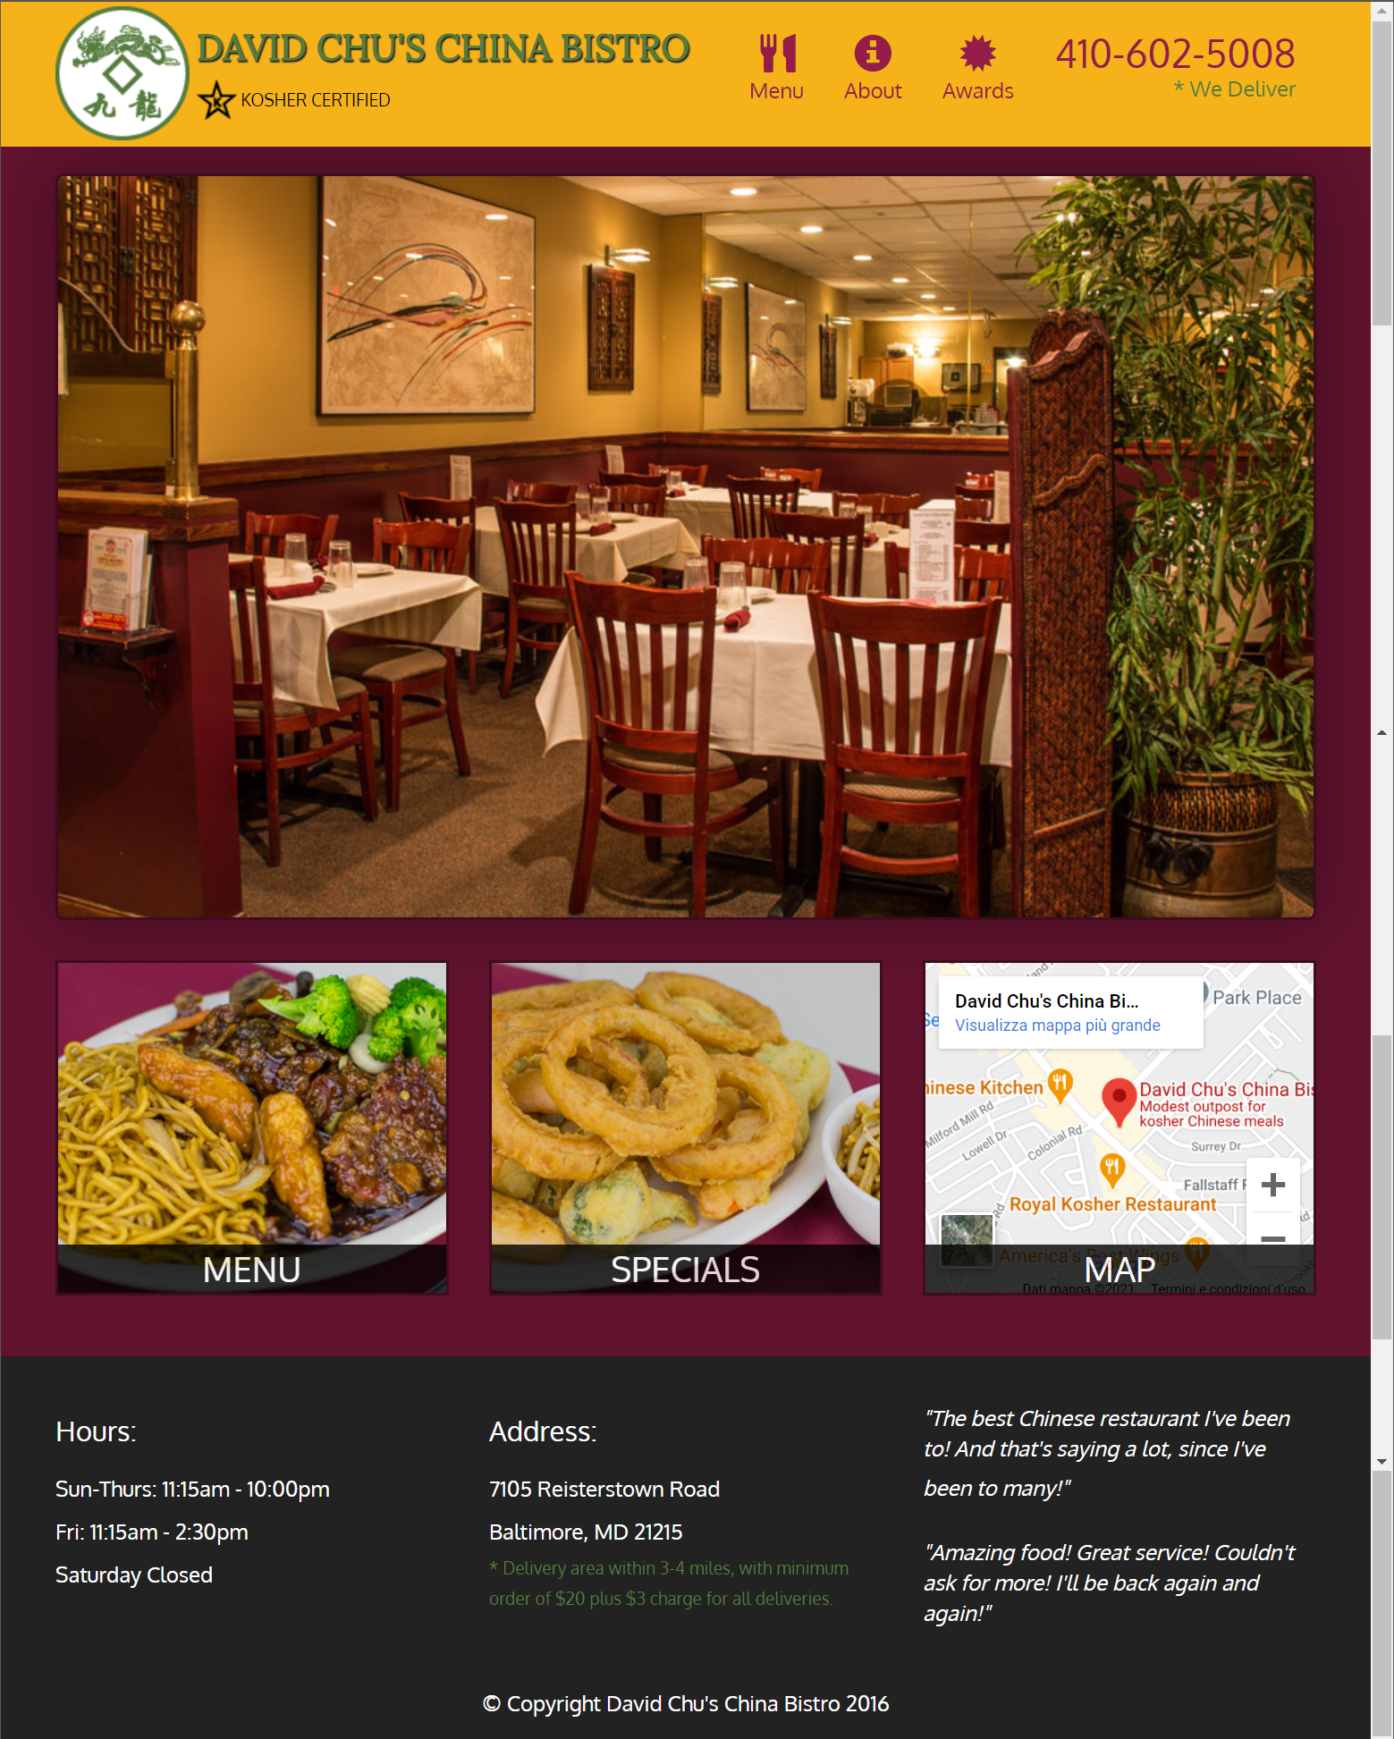

## Breakpoint xl (>=1200px)

